A example of a sophisticated print shop
Object-Oriented component design
The overall intent of the software is to collect the customer’s requirements at the front counter, cost a print job, and then pass the
job on to an automated production facility. During requirements engineering,an analysis class called PrintJob was derived. The attributes and operations defined during analysis are noted at the top of Figure 14.1. During architectural design, PrintJob is defi ned as a component within the software architecture and is represented using the shorthand UML notation shown in the middle right of the figure. Note that PrintJob has two interfaces, computeJob, which provides job costing capability, and initiateJob, which passes the job along to the production facility. These are represented using the “lollipop” symbols shown to the left of the component box.
Component-level design begins at this point. The details of the component
PrintJob must be elaborated to provide suffi cient information to guide implementation.The original analysis class is elaborated to fl esh out all attributes and operations required to implement the class as the component PrintJob. Referring to the lower right portion of Figure 14.1 , the elaborated design class PrintJob contains more detailed attribute information as well as an expanded description of operations required to implement the component. The interfaces compute-Job and initiateJob imply communication and collaboration with other components (not shown here). For example, the operation computePageCost() (part of the computeJob interface) might collaborate with a PricingTable component that contains job pricing information. The checkPriority() operation (part of the initiateJob interface) might collaborate with a JobQueue component to determine the types and priorities of jobs currently awaiting production.

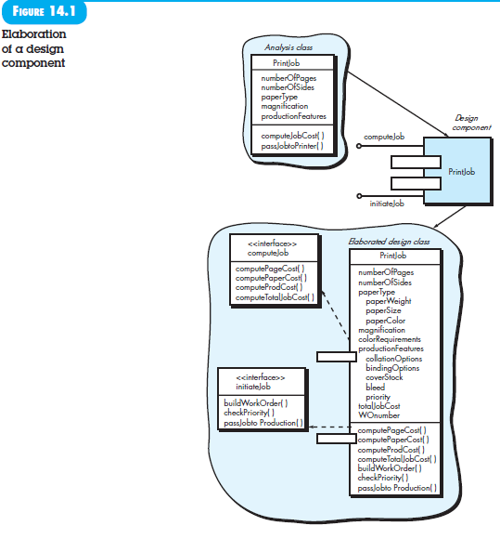

An The Traditional component design
To illustrate this process of design elaboration for traditional components, again consider software to be built for a sophisticated print shop. A hierarchical architecture is derived and shown in Figure 14.2 . Each box represents a software component. Note that the shaded boxes are equivalent in function to the operations defined for the PrintJob class discussed in Section 14.1.1. In this case, however, each operation
is represented as a separate module that is invoked as shown in the figure. Other modules are used to control processing and are therefore control components.
During component-level design, each module in Figure 14.2 is elaborated. The module interface is defined explicitly. That is, each data or control object that flows across the interface is represented. The data structures that are used internal to the module are defined. The algorithm that allows the module to accomplish its intended function is designed using the stepwise refinement approach discussed in Chapter 12. The behavior of the module is sometimes represented using a state diagram. To illustrate this process, consider the module ComputePageCost. The intent of this module is to compute the printing cost per page based on specifications provided by the customer. Data required to perform this function are: number of pages in the document, total number of documents to be produced, one- or two-side printing, color requirements,and size requirements. These data are passed to ComputePageCost via the module’s interface. ComputePageCost uses these data to determine a page cost that is based on the size and complexity of the job—a function of all data passed to the module via the interface. Page cost is inversely proportional to the size of the job and directly proportional to the complexity of the job.
Figure 14.3 represents the component-level design using a modified UML
notation. The ComputePageCost module accesses data by invoking the module
getJobData, which allows all relevant data to be passed to the component, and a database interface, accessCostsDB, which enables the module to access a database that contains all printing costs. As design continues, the ComputePageCost module is elaborated to provide algorithm detail and interface detail ( Figure 14.3 ). Algorithm detail can be represented using the pseudocode text shown in the figure or with a UML activity diagram. The interfaces are represented as a collection of input and output data objects or items. Design elaboration continues until sufficient detail is provided to guide construction of the component.

